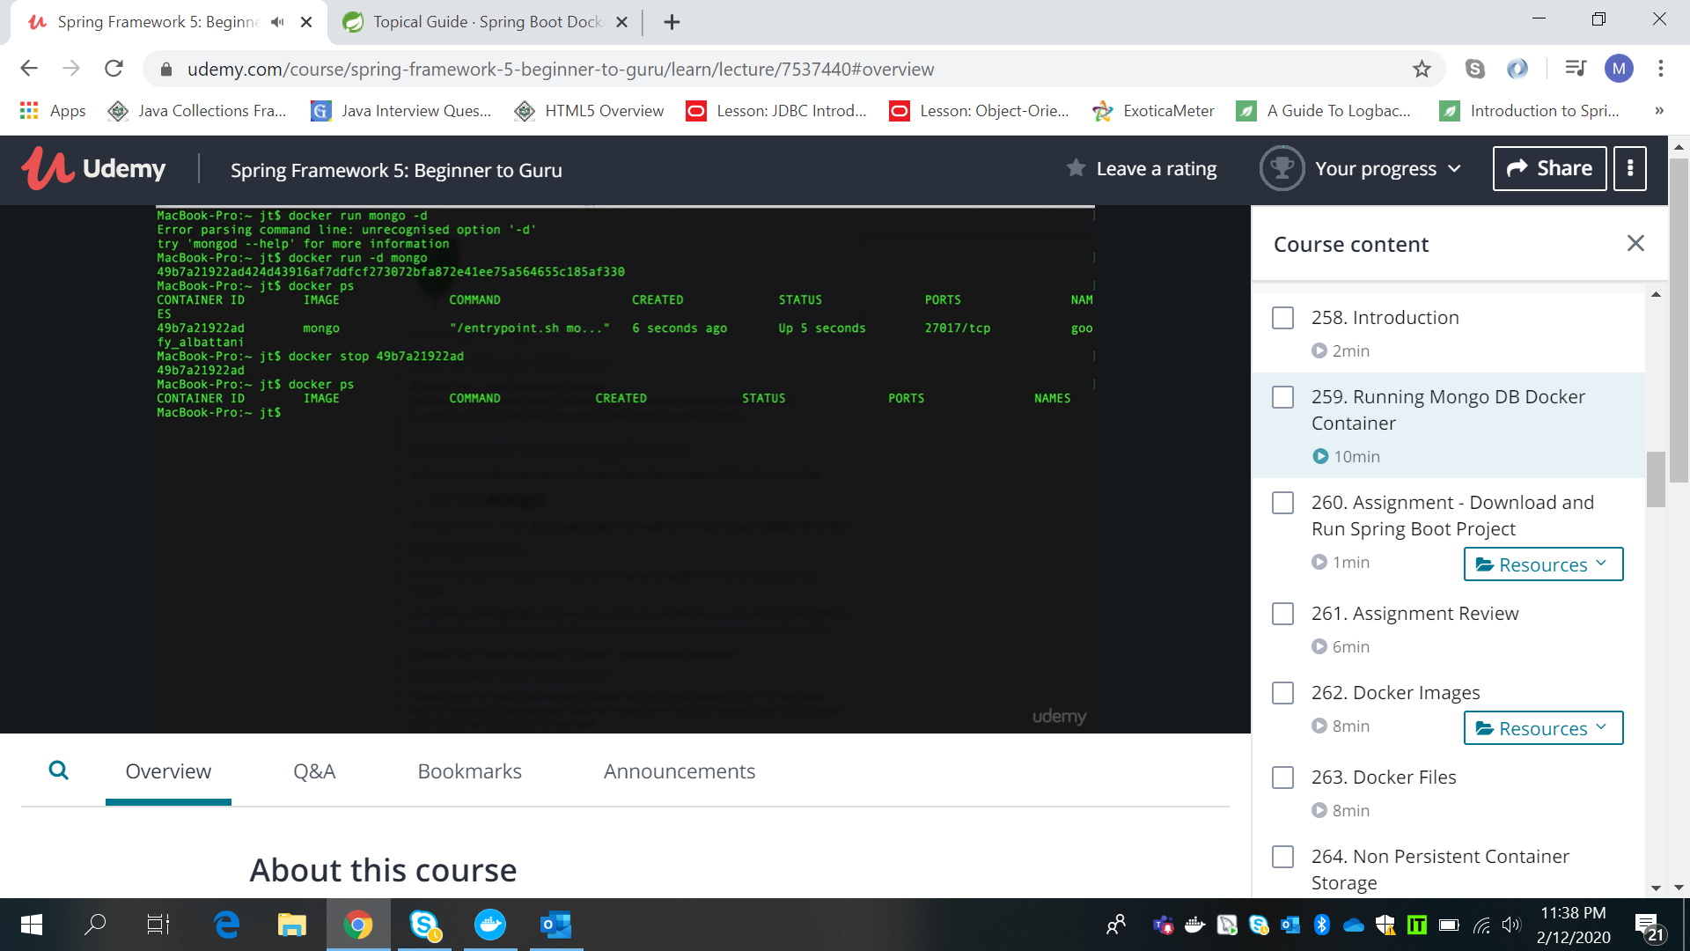

Docker run -p port:port -d mongo

Docker logs -f <id>

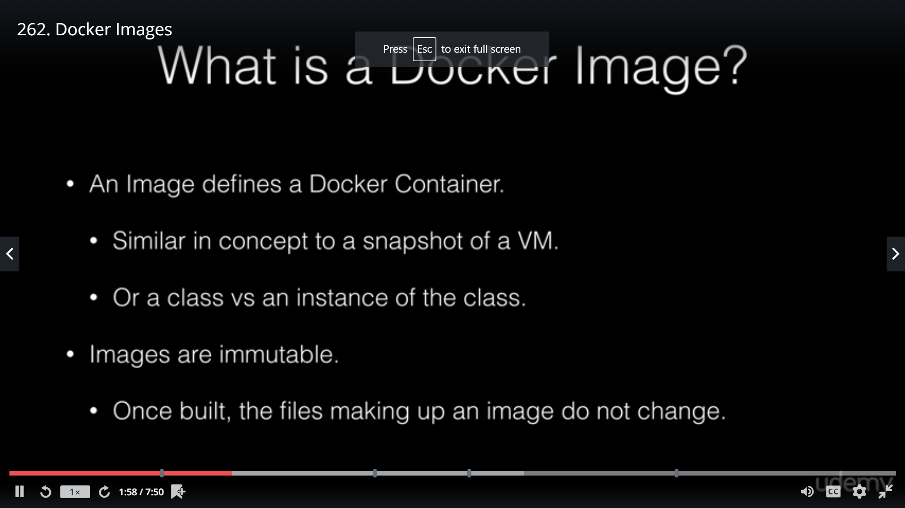

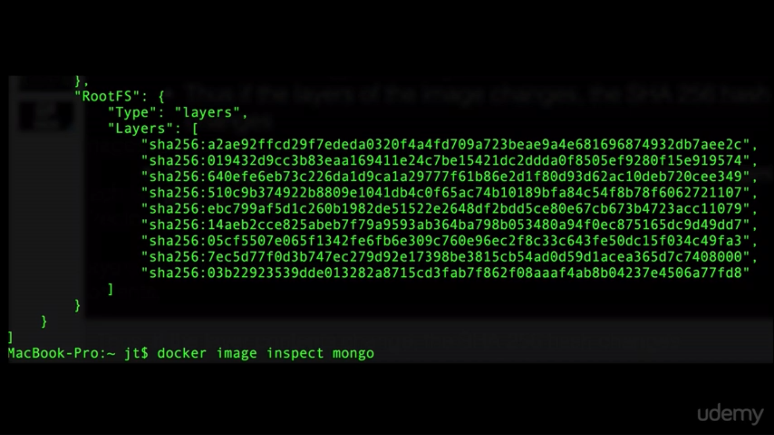

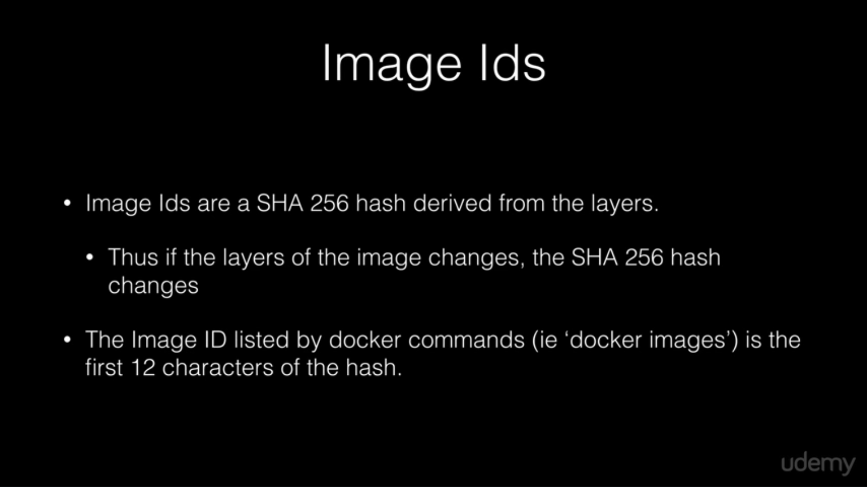

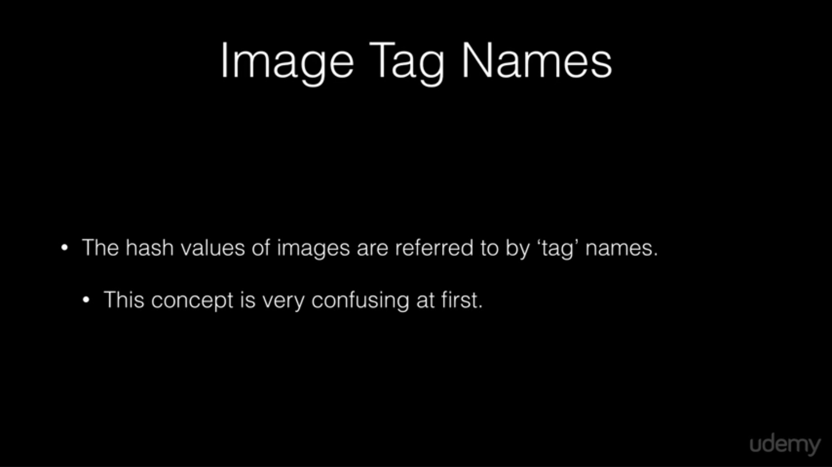

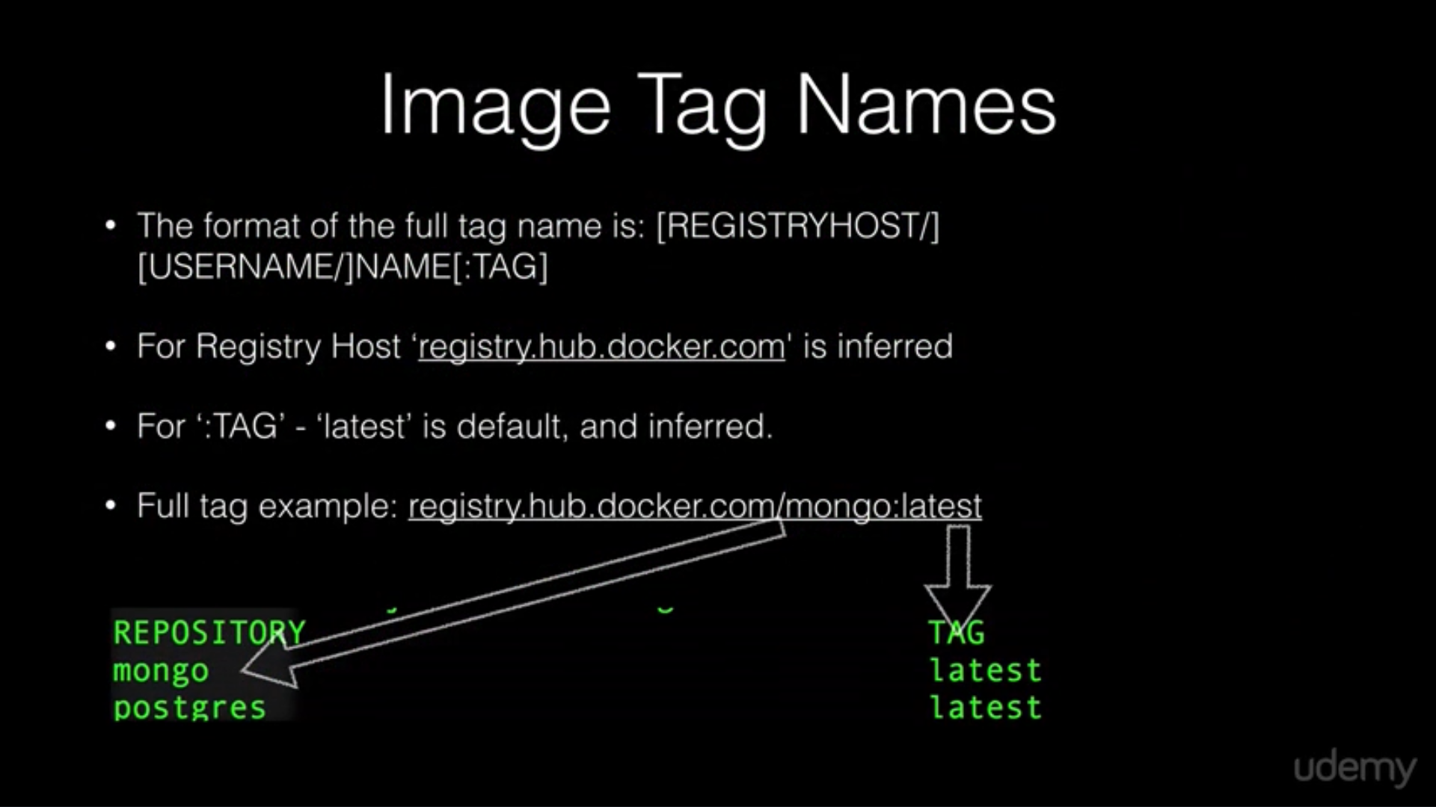

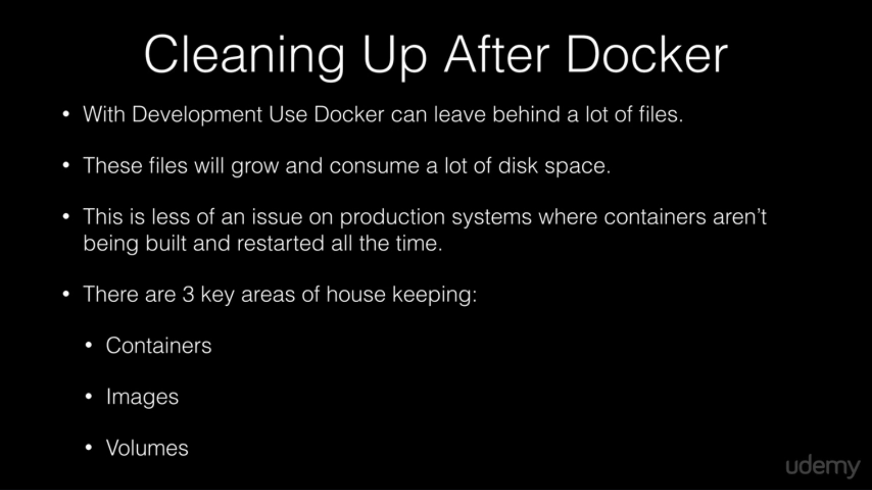

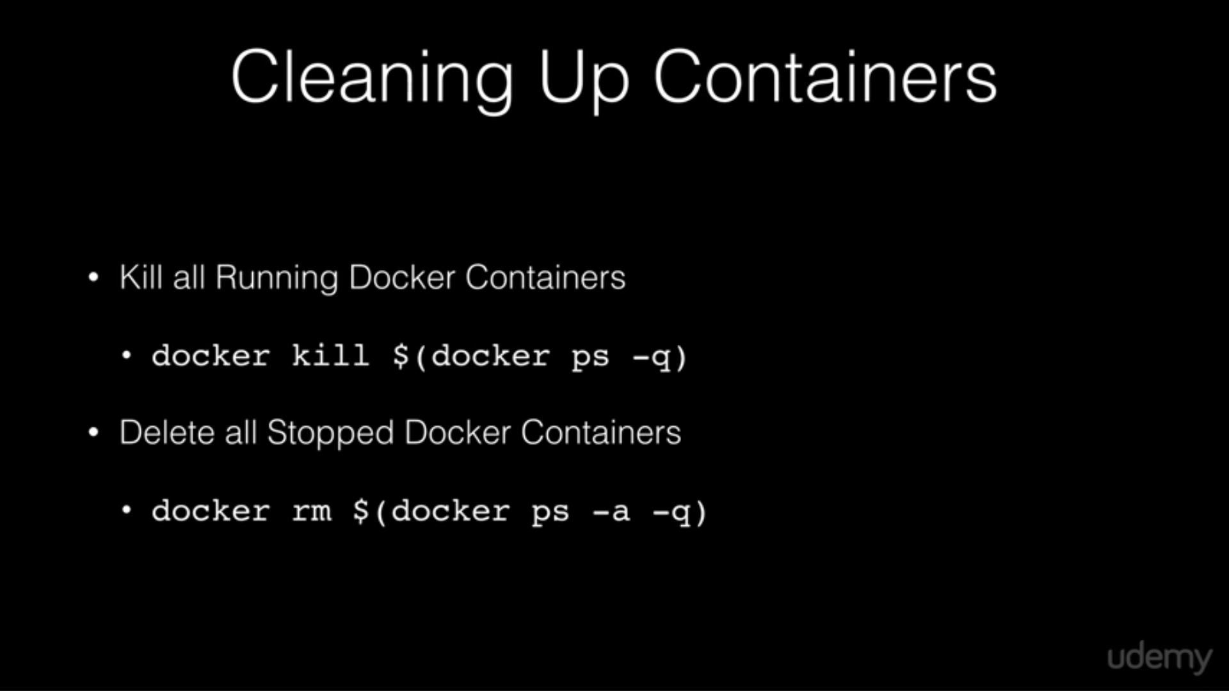

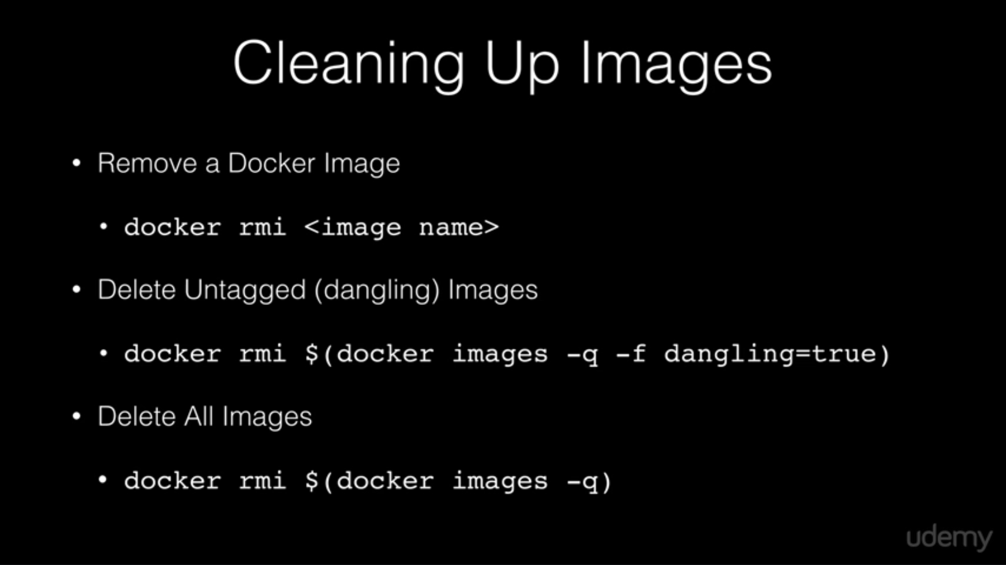

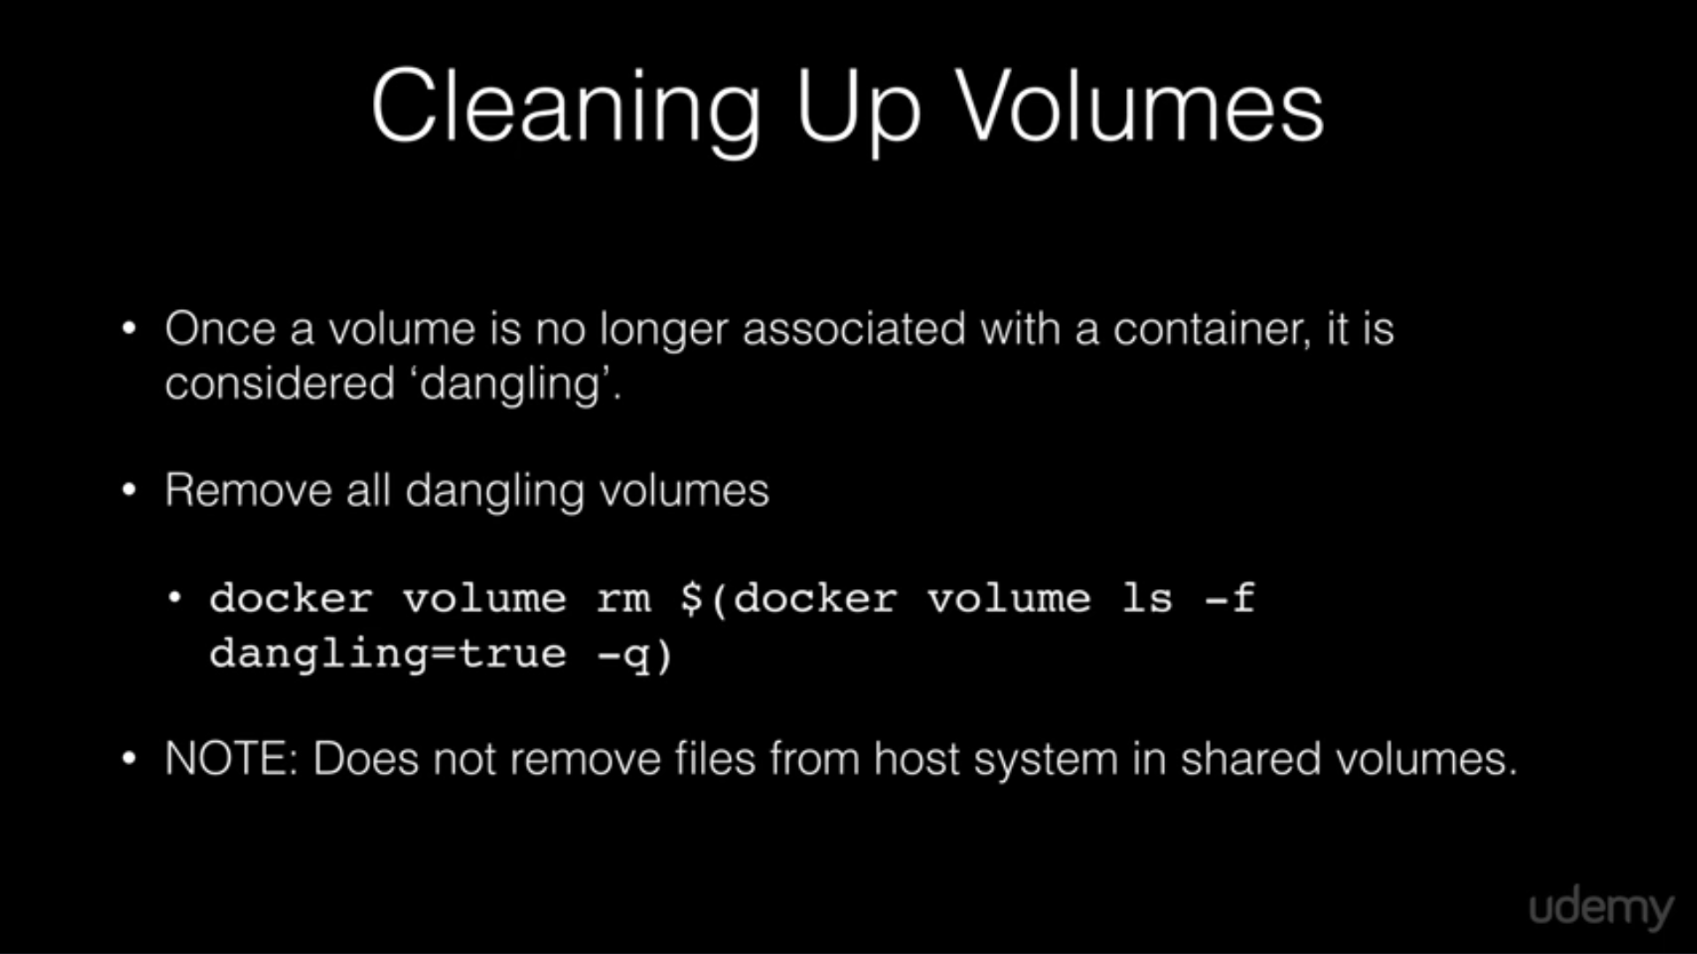

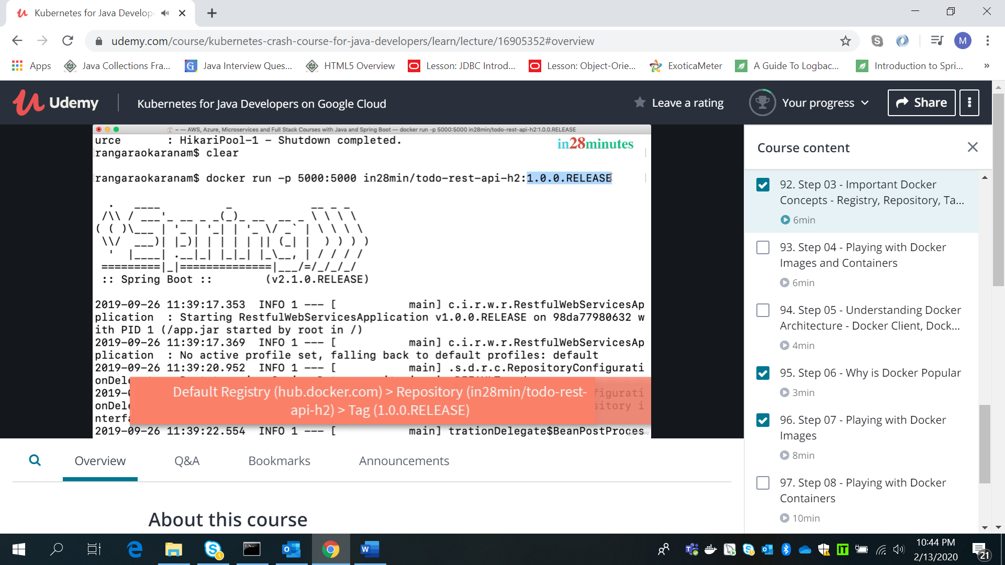

Docker logs -f <container ID>

Docker container ls -a

Docker images

Docker container stop <container id>

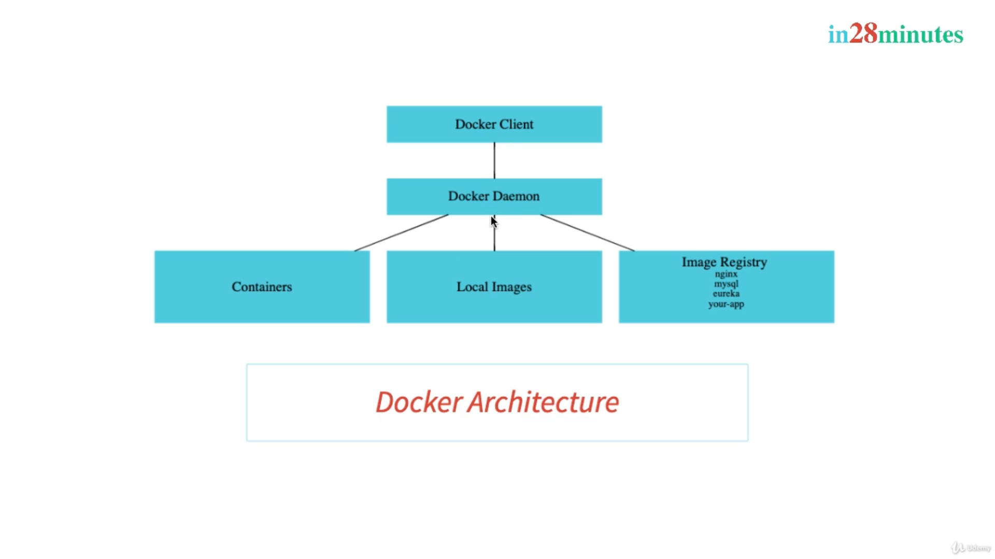

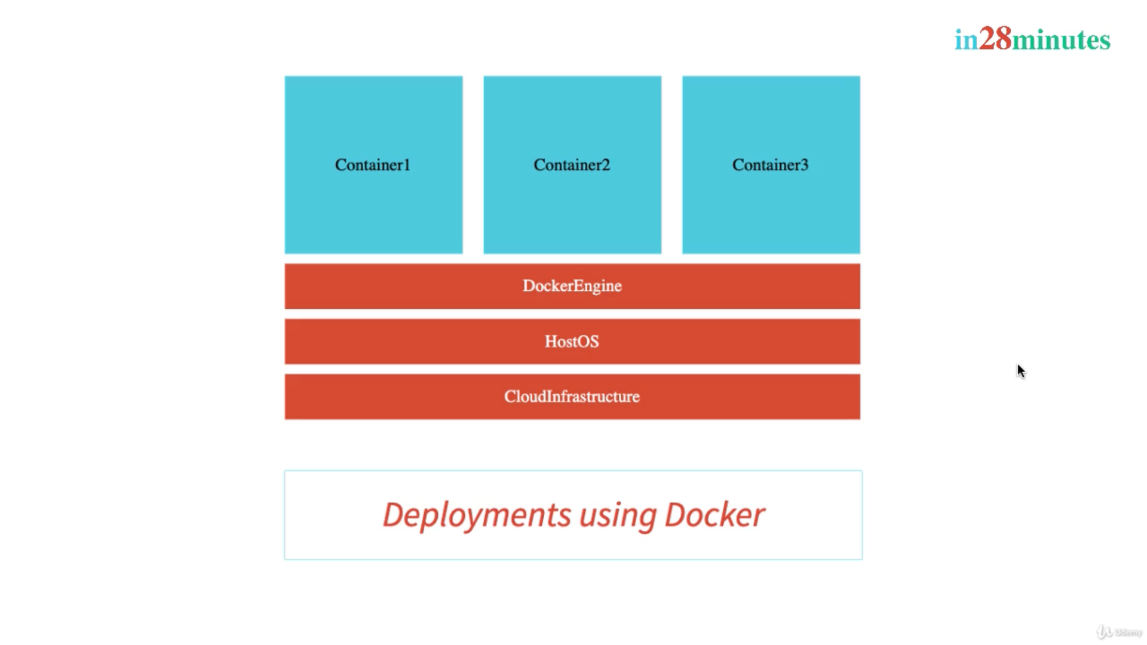

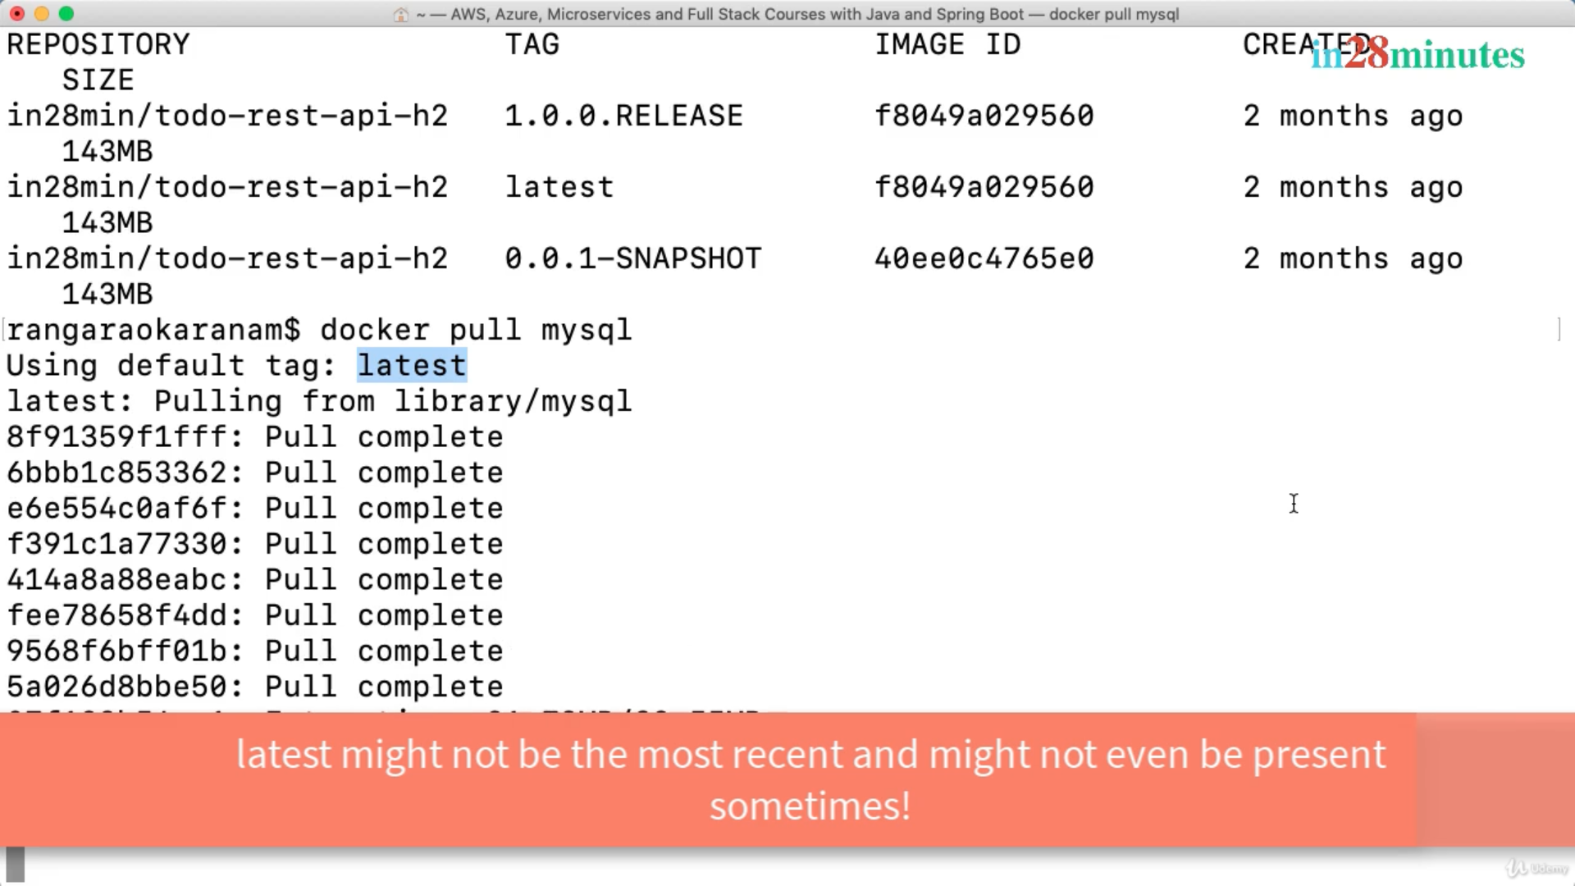

Docker search <imagename>

Docker image history <imaged or repository:tag>

Docker image inspect <imageid>

Docker image remove <imageid>

Docker container pause <container id>

Docker container unpause <container id>

Docker container inspect <container ID>

Docker container prune – this will remove all stopped containers

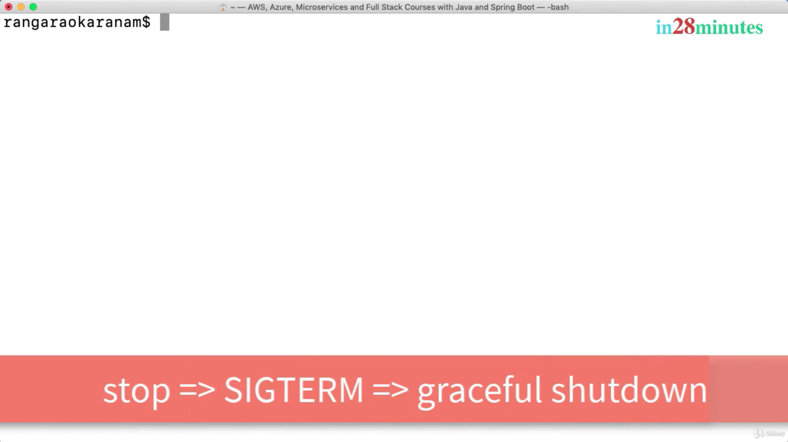

Docker container kill <container id> (SIGKILL)

Docker run -restart=always/default is no – it will start container when docker engine i.e docker deamon is restarted.

Docker events – to track events on docker engine.

Docker top <running container id> this will list running process in container

Docker stats this will give details on CPU/memory used by running containers

